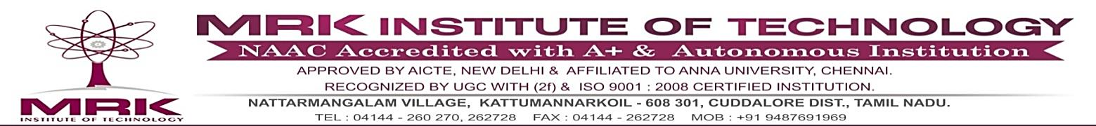**DEPARTMENT OF SCIENCE AND HUMANITIES**

**YEAR/SEM : I/I BATCH: 2024-2028**

**SUB CODE/ TITLE: 3354 DISCRETE MATHEMATICS**

**CONTENT BEYOND THE SYLLABUS**

**LEARNING WITH MULTI-MEDIA**

**By using lcd projector for power point presentation**

**TOPIC:**

**RECURRENCE RELATIONS**

**YOUTUBE LINK :** <https://regenesis.com/en/functions> of sevaral variable methods /

**SUBJECT INCAHRGE HOD**